6/1/22

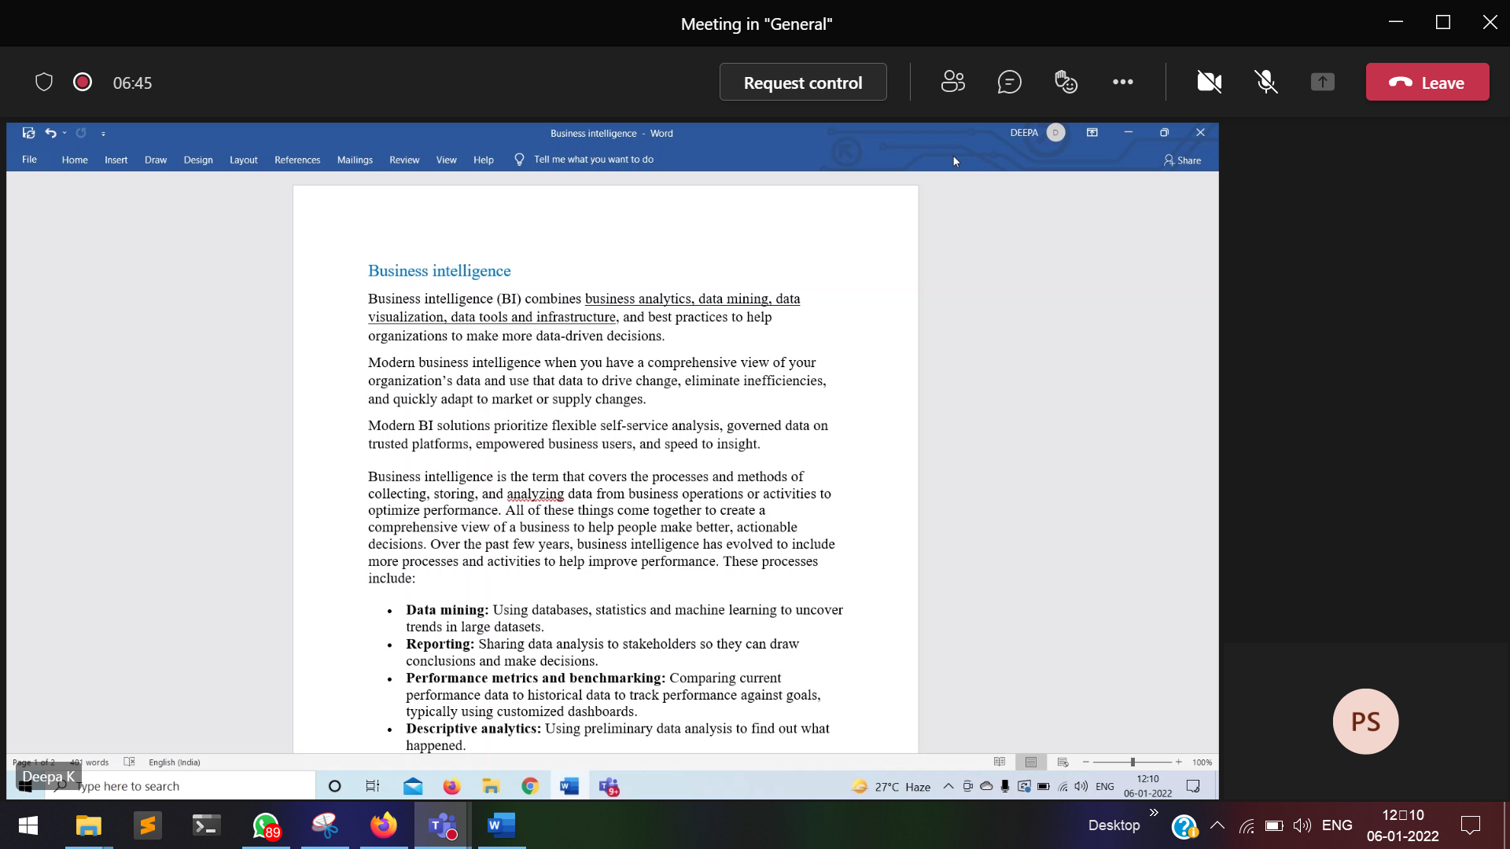

7/1/22

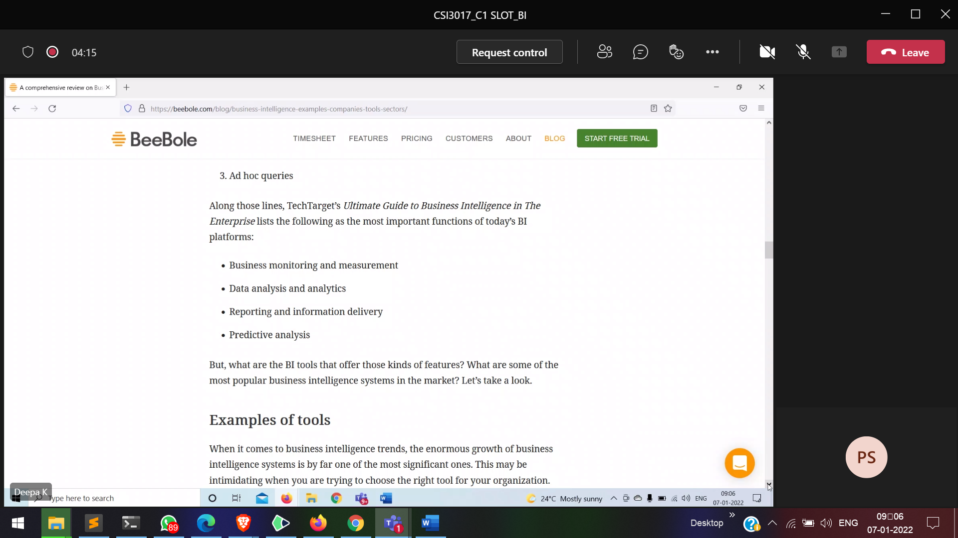

<https://beebole.com/blog/business-intelligence-examples-companies-tools-sectors/>

11/1/22

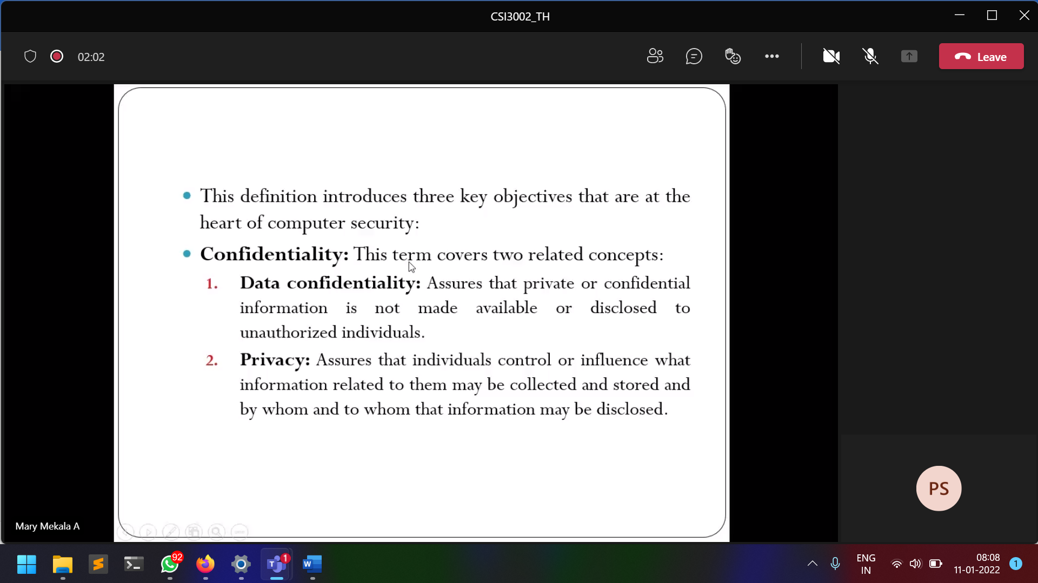

12/1/22

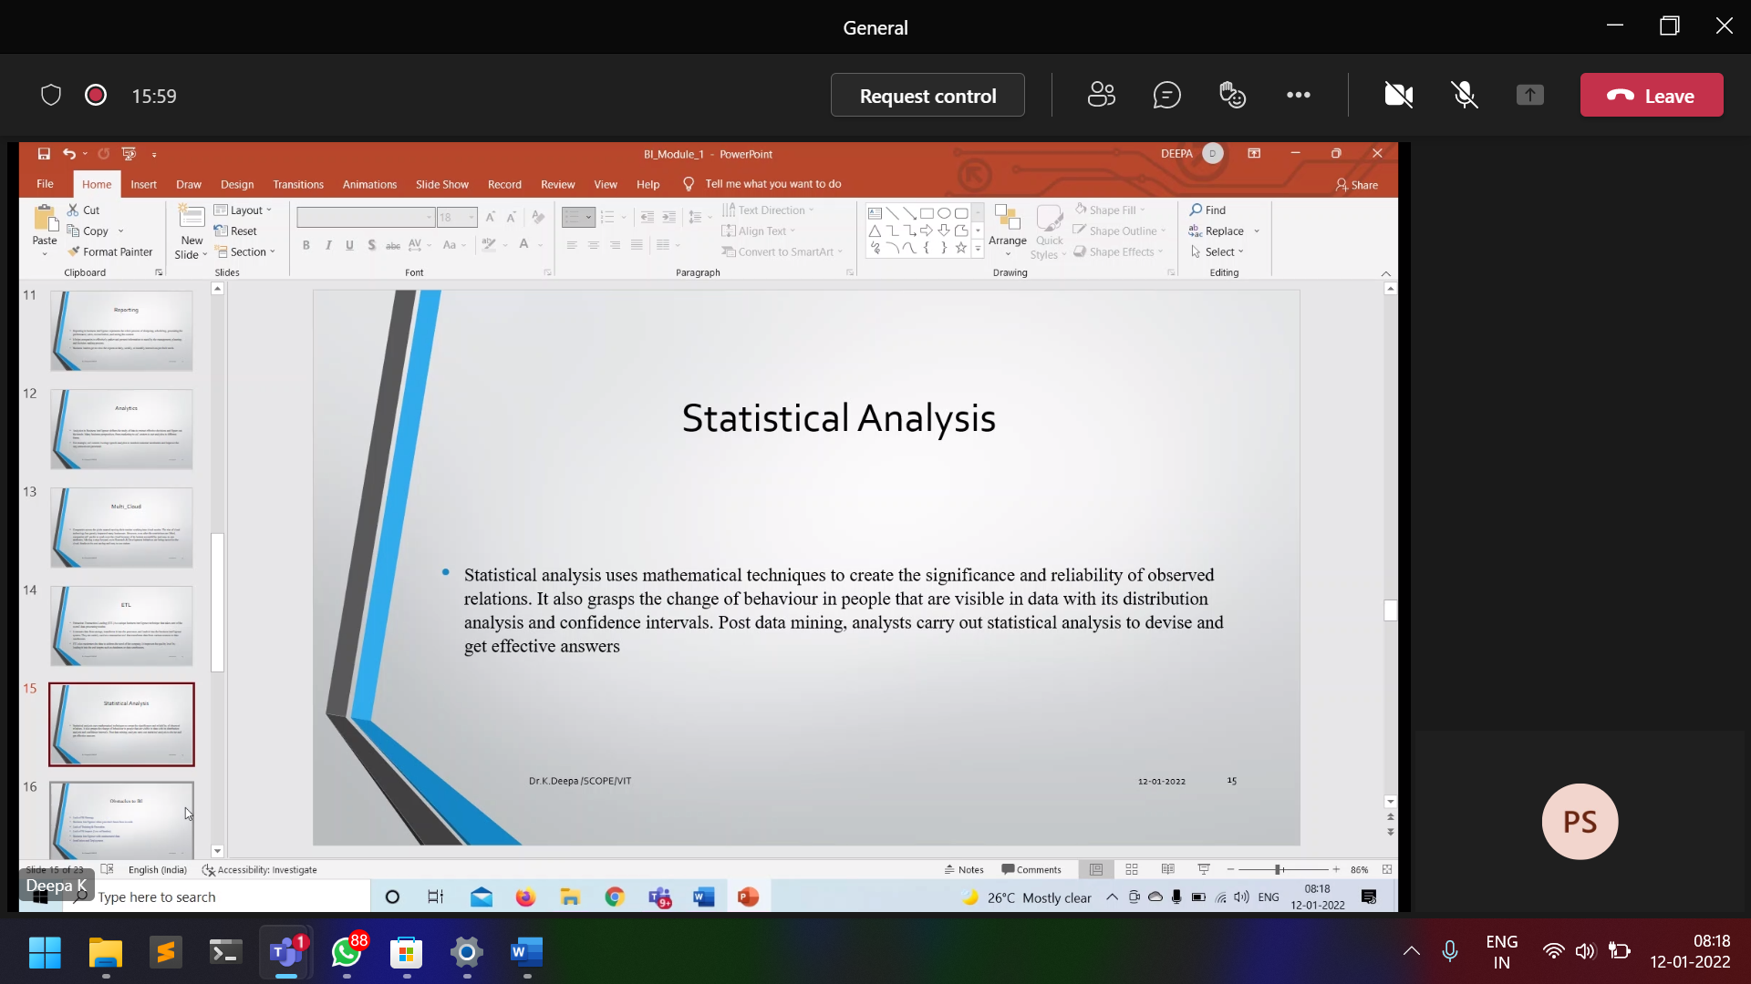

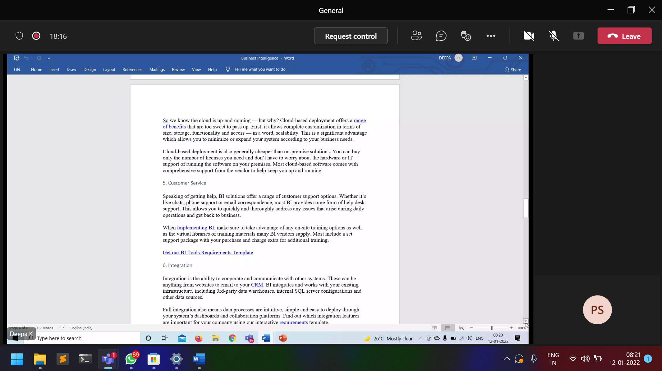

19/1/22

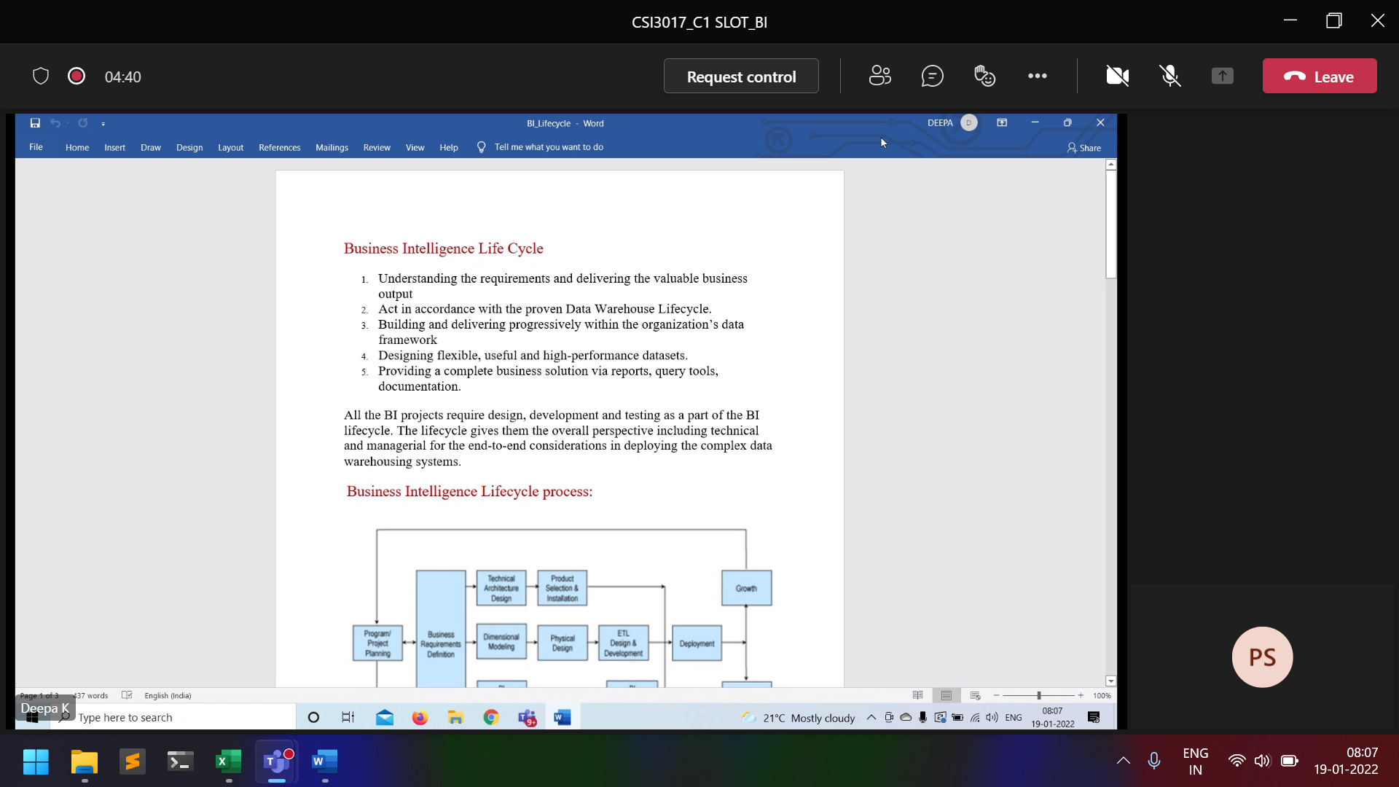

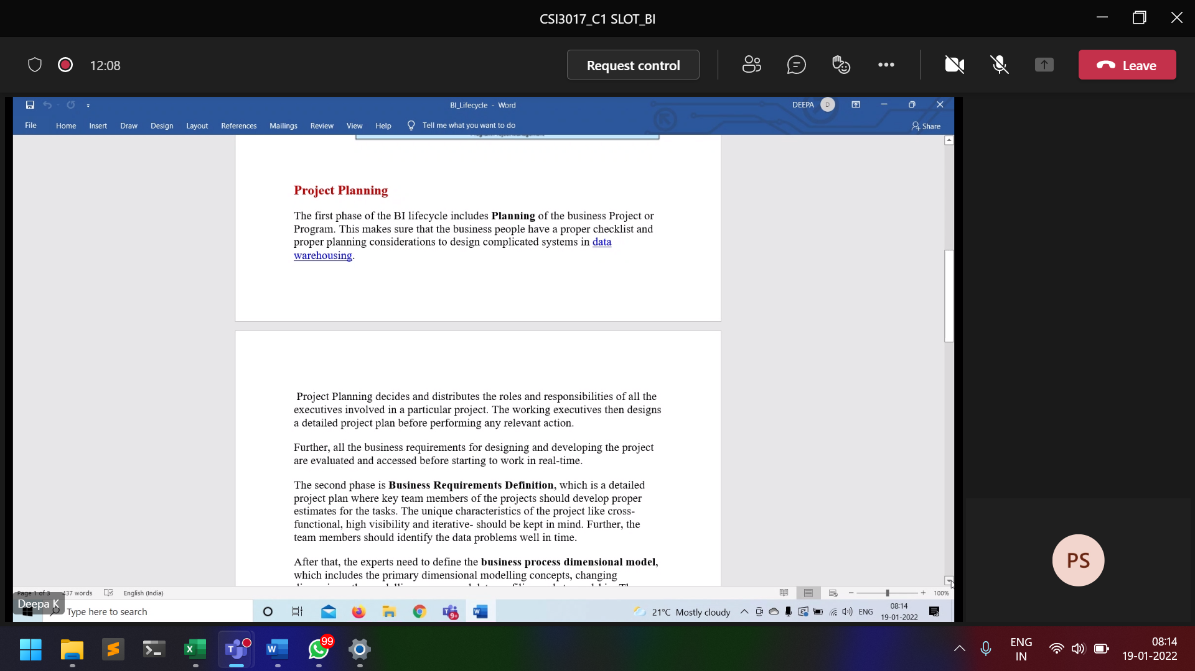

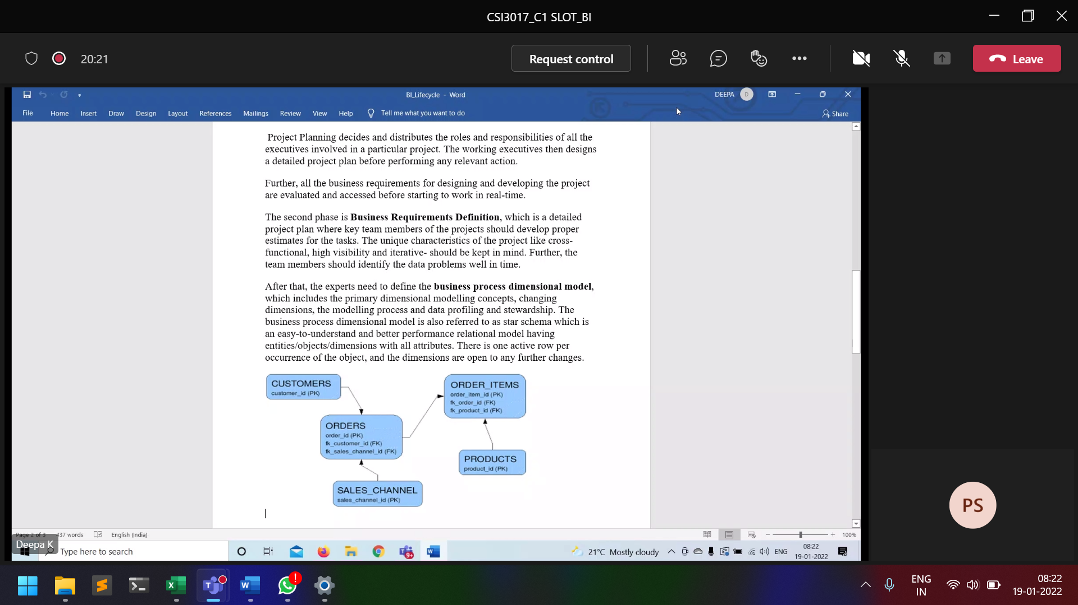

21/1/22

27/1/22

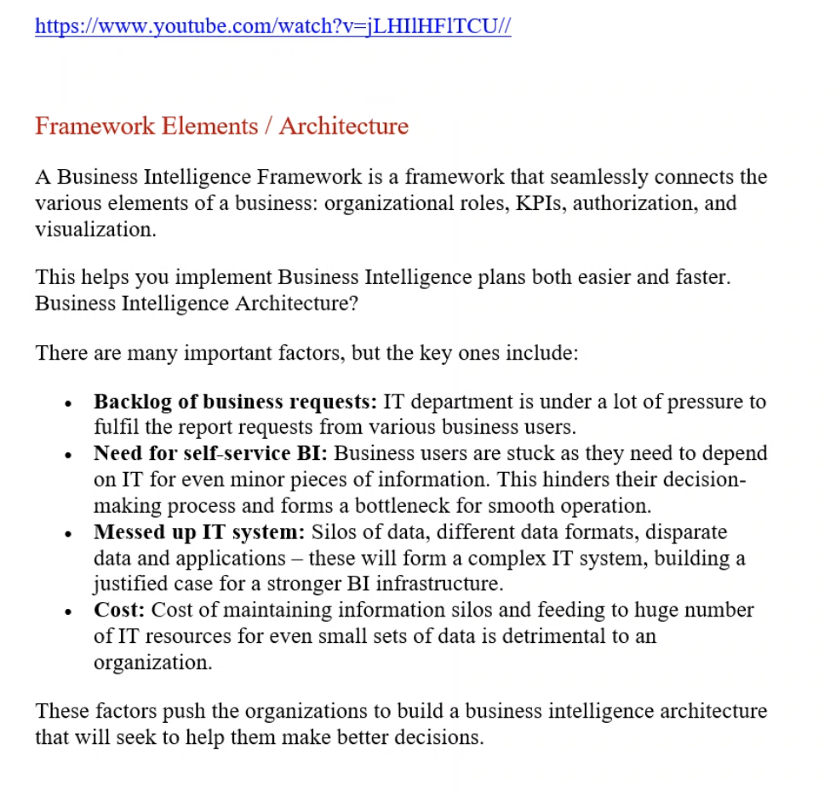

28/1/22

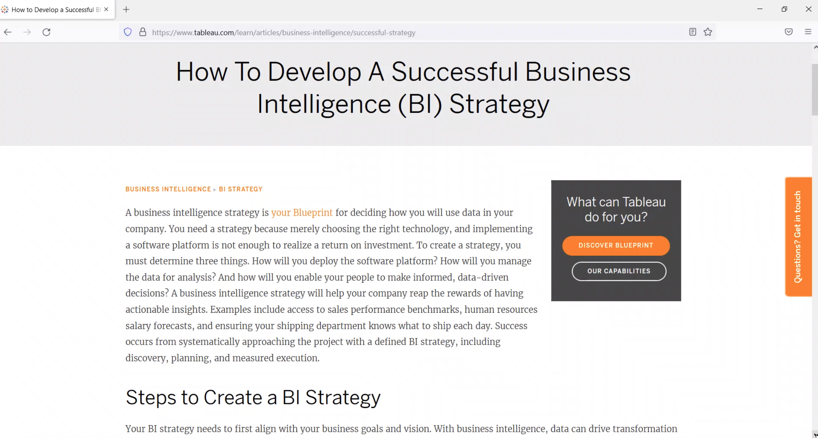

1/2/22

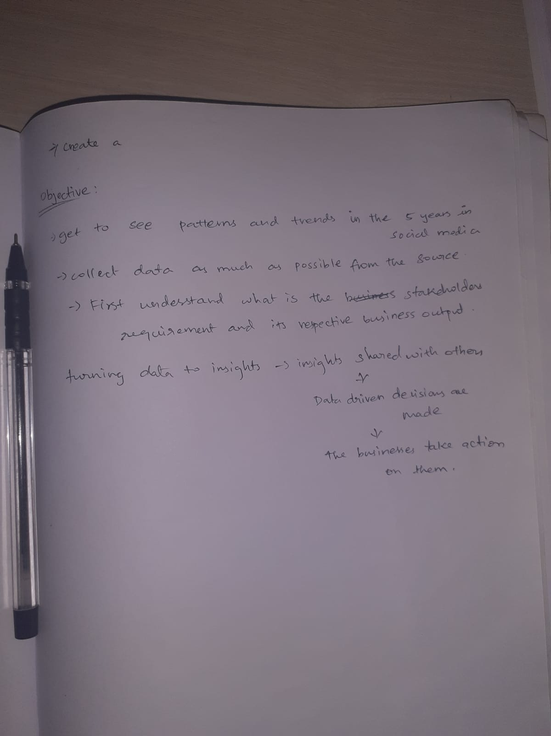

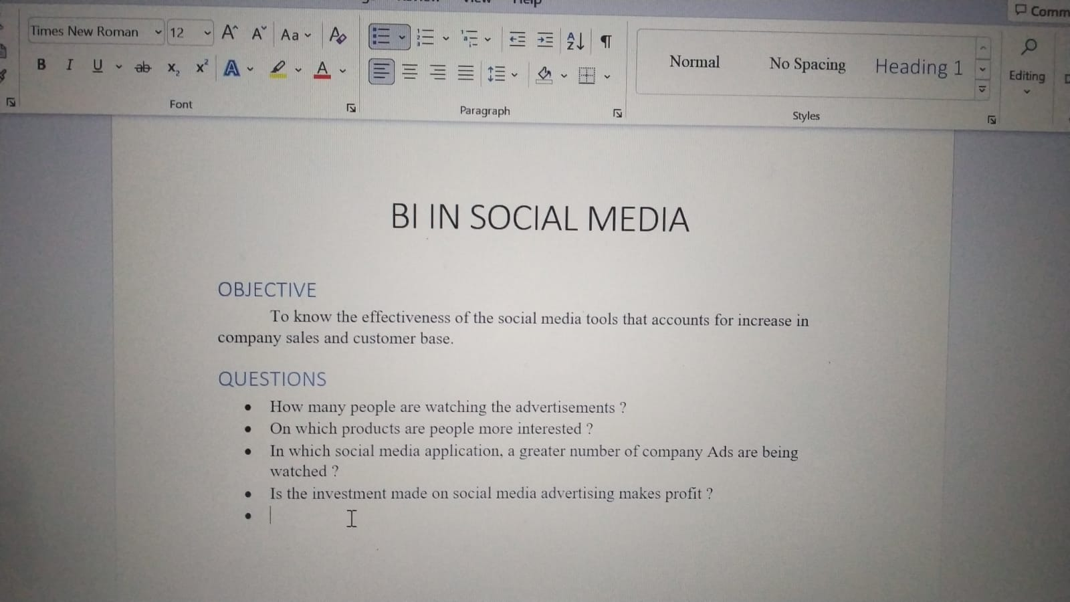

3/2/22

https://www.altexsoft.com/blog/business-intelligence-strategy/

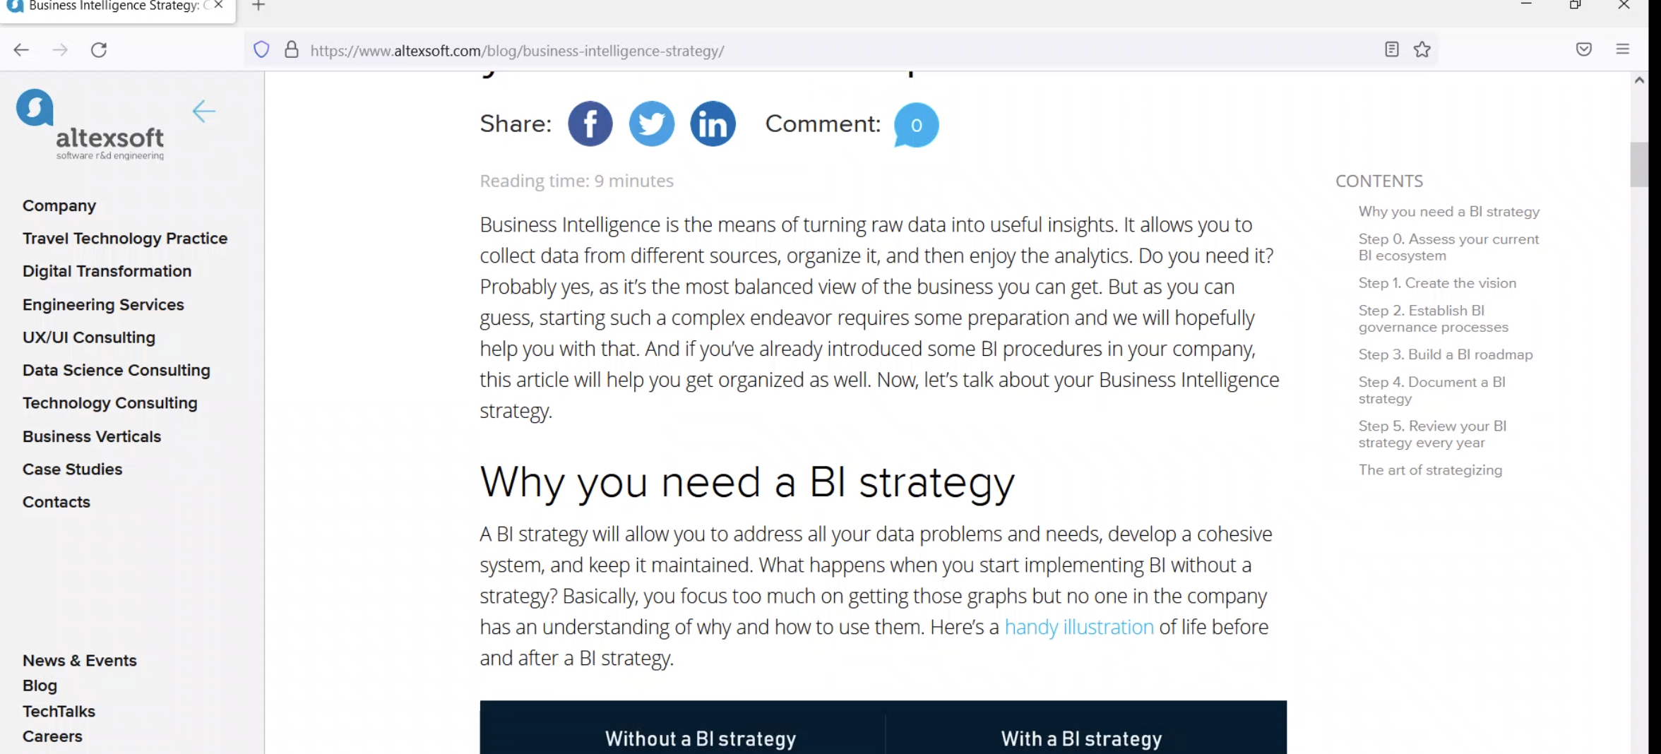

8/2/22

9/2/22

References

Business Intelligence: What It Is & Its Importance | Tableau

https://www.tableau.com/learn/articles/business-intelligence

A comprehensive review on Business Intelligence: Examples, BI tools and Everything Else You Need to Know

https://beebole.com/blog/business-intelligence-examples-companies-tools-sectors/

23 Real-World Examples of Business Intelligence | NetSuite

https://www.netsuite.com/portal/resource/articles/business-strategy/business-intelligence-examples.shtml

Power BI

https://app.powerbi.com/home

Power BI on Microsoft Learn | Microsoft Docs

https://docs.microsoft.com/en-us/learn/powerplatform/power-bi?WT.mc_id=powerbi_landingpage-docs-link

How to Develop a Successful BI Strategy | Tableau

https://www.tableau.com/learn/articles/business-intelligence/successful-strategy

Business Intelligence Strategy: Creating Your BI Roadmap | AltexSoft

https://www.altexsoft.com/blog/business-intelligence-strategy/

What is Business Intelligence (BI): Complete Implementation Workflow | AltexSoft

https://www.altexsoft.com/blog/business/complete-guide-to-business-intelligence-and-analytics-strategy-steps-processes-and-tools/

Parallel Development Tracks | Business Intelligence Roadmap: The Complete Project Lifecycle for Decision-Support Applications

https://flylib.com/books/en/4.49.1.20/1/

4/2/22

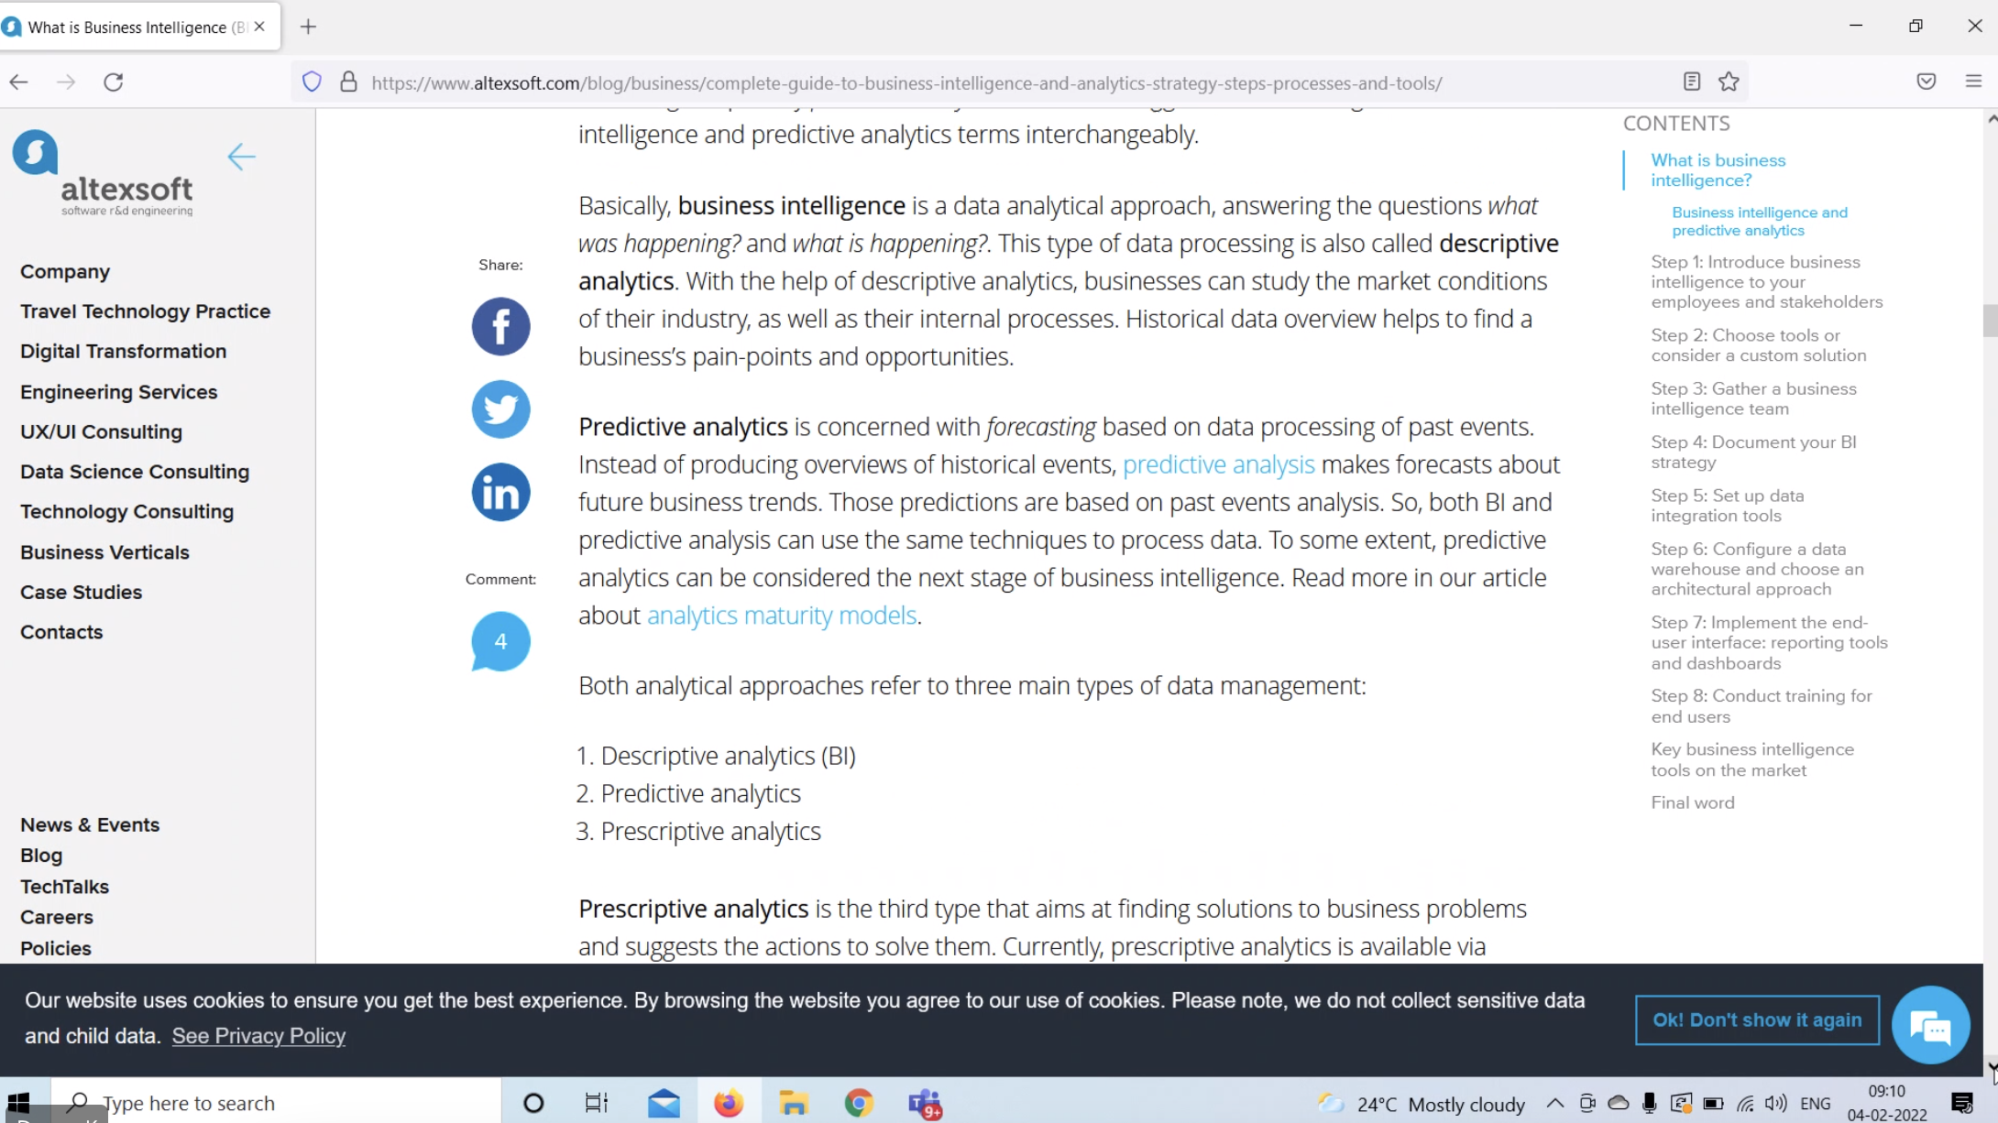

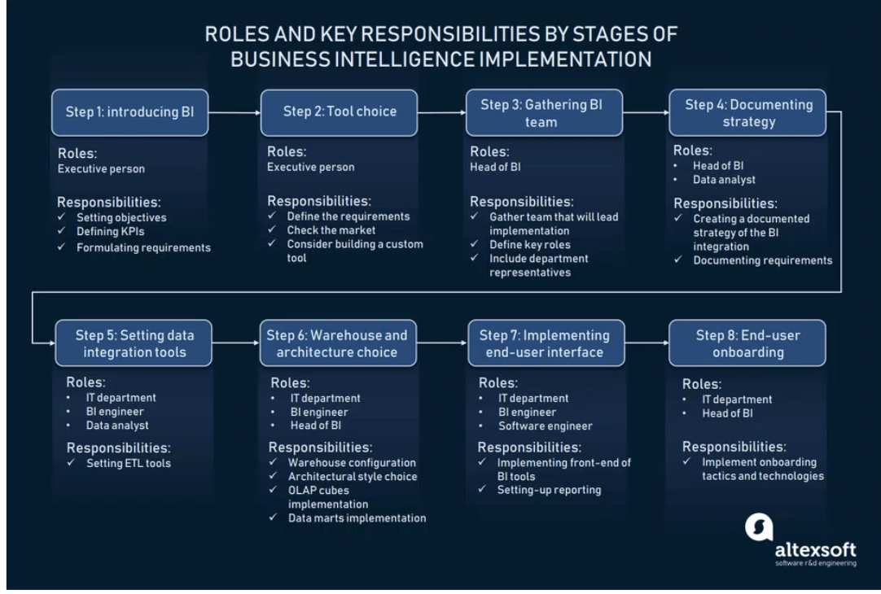

<https://www.altexsoft.com/blog/business/complete-guide-to-business-intelligence-and-analytics-strategy-steps-processes-and-tools/>

<https://www.altexsoft.com/blog/business-intelligence-strategy/>

10/2/22

